MEMORIAL REQUEST FORM
Contact Person: ______________________________________________
Street Address: ______________________________________________
City, State, Zip: ______________________________________________
Phone #: ______________________________________________
Email Address: ______________________________________________
MEMORIAL PLAQUE (4 lines max):
_____________________________________________________________
_____________________________________________________________
_____________________________________________________________
_____________________________________________________________
PARK IN WHICH DONATION IS TO BE PLACED:
___ Police Cove Park
___ Latham Park
___ Veterans Memorial Park
___ Osamequin Nature Trails
___ Town Beach
___ Other _______________________________________________
COST: ____________ Check #: ____________ Payment Date: ____________
Date Ordered: ____________ Date Installed: ____________
Donor’s Signature _________________________ Date ____________
Parks & Rec. Dir. Approval __________________ Date ____________
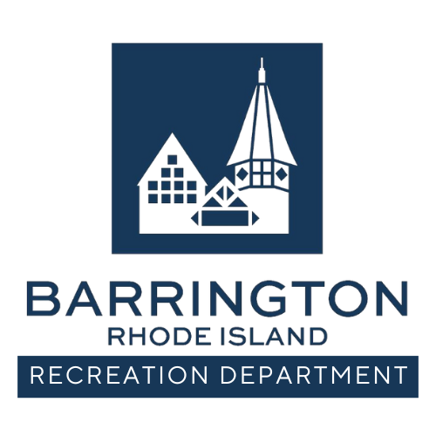
MEMORIAL PROGRAM OVERVIEW
The Town of Barrington Recreation Department offers a Memorial Program for those wishing to contribute to the beauty of public parks and open spaces by purchasing a bench, shrub, and/or tree installed in honor or memory of a loved one.
Memorial benches provide a place of rest and reflection for visitors while enhancing public spaces. Benches, shrubs, or trees may be installed seasonally, weather permitting. Donors will be notified once the bench, tree, shrub and plaque have been installed. The Town cannot guarantee a specific installation date.
All memorial items will be installed by the Town of Barrington Department of Public Works. Donors are not permitted to add flowers, decorations, or additional plantings to the memorial area.
COMMEMORATIVE PLAQUE:
Each memorial includes a cast plaque, approximately 8" x 5", with up to four lines of text. Plaque wording must be approved by the donor and the Recreation Department prior to production.
PURCHASE AND INSTALLATION:
A completed Memorial Request Form is required. Once availability and pricing are confirmed, the Town will order the bench upon receipt of payment. Installation will be coordinated with the Department of Public Works. Donors will be contacted upon completion.

